Deploying a VM using an ARM Template in
Azure SOP



Table of Contents

1. Deploying a VM using an ARM Template in Azure 3
1.1 Description 3
1.2 Architecture Diagram 3
1.3 Lab Steps 4
1.4 Troubleshooting 4
1.5 Supporting References 4

Deploying a VM using an ARM Template in Azure

Description
The objective of this lab exercise is to create and deploy a Virtual Machine (Linux) using the Azure Resource
Manager (ARM). ARM Templates are a way to declare the objects, the types, names and properties in a JSON file which can be checked into source control and managed like any other code file. ARM Templates are what really gives the ability to roll out Azure Infrastructure as code which is the process of managing and provisioning computer data centres through machine-readable definition files.

Architecture Diagram
The diagram below displays a visual representation of the application architecture:
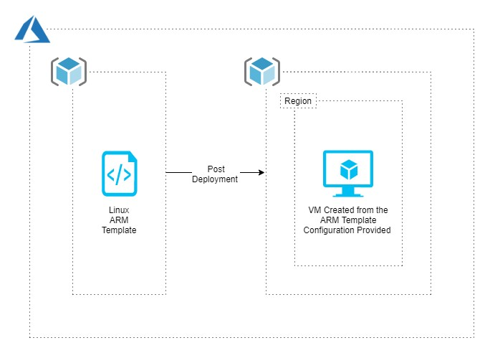

Lab Steps
Follow the steps outlined below to achieve the objective of this lab exercise:

- Go to the Resource group for your user (<Dept><empID>RG).
- Click Add and Search for templates. Choose Template deployment (deploy using custom templates).
- Click Create.
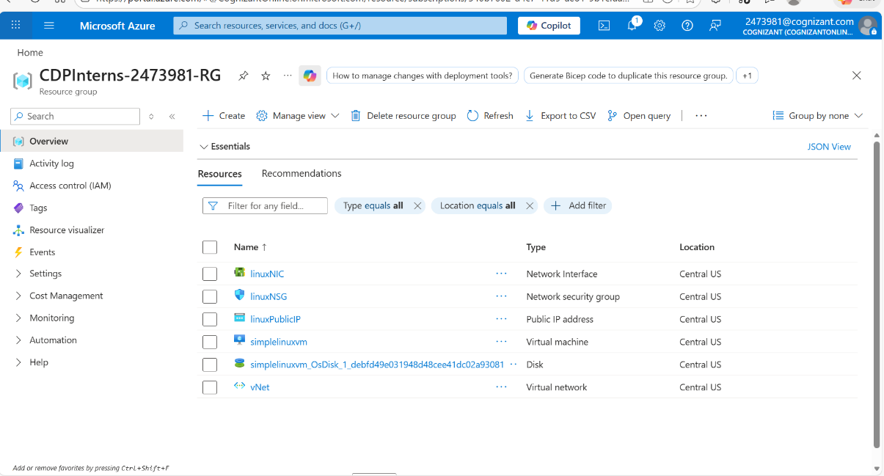
- Under Common templates, choose Create a Linux virtual machine.
- If you are not able to select the above template, copy the json from the GitHub link displayed in message and paste it in Build your Own template in the Editor.
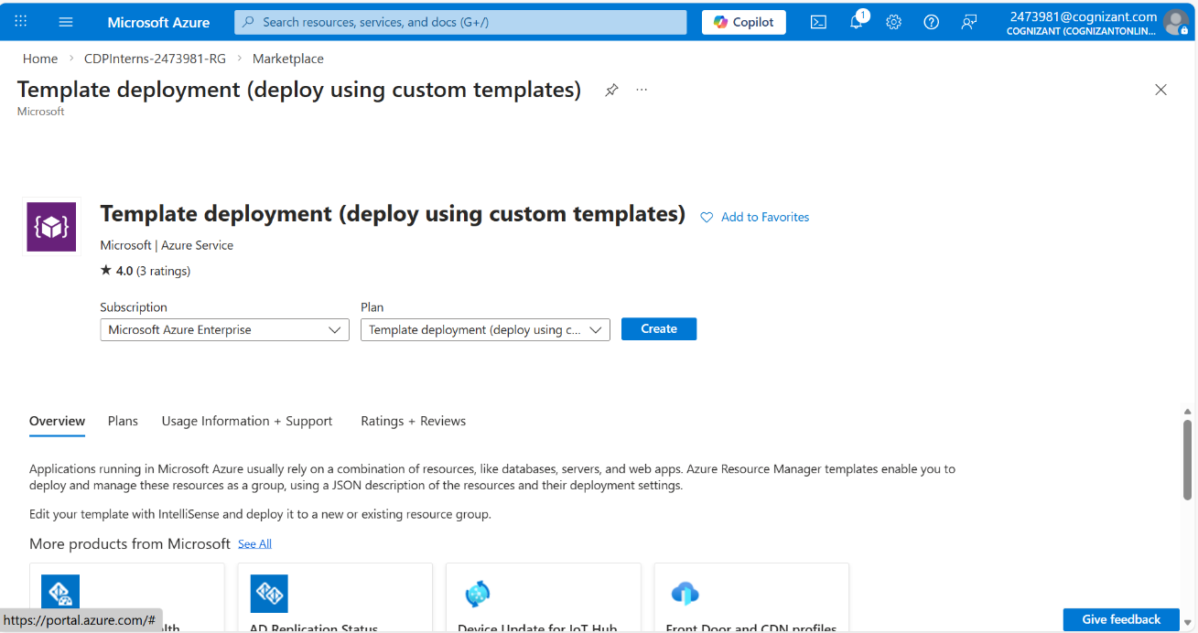
- Under Basics, Select the Resource group as AzureTeam1-RG and Location as East US.
- Under Settings, give the VM a name, Admin Username, choose authentication type as password, give a password for the same and set the VM Size as Standard_B1s according to the policy set.
- Select the I agree to the terms and conditions stated above check box.
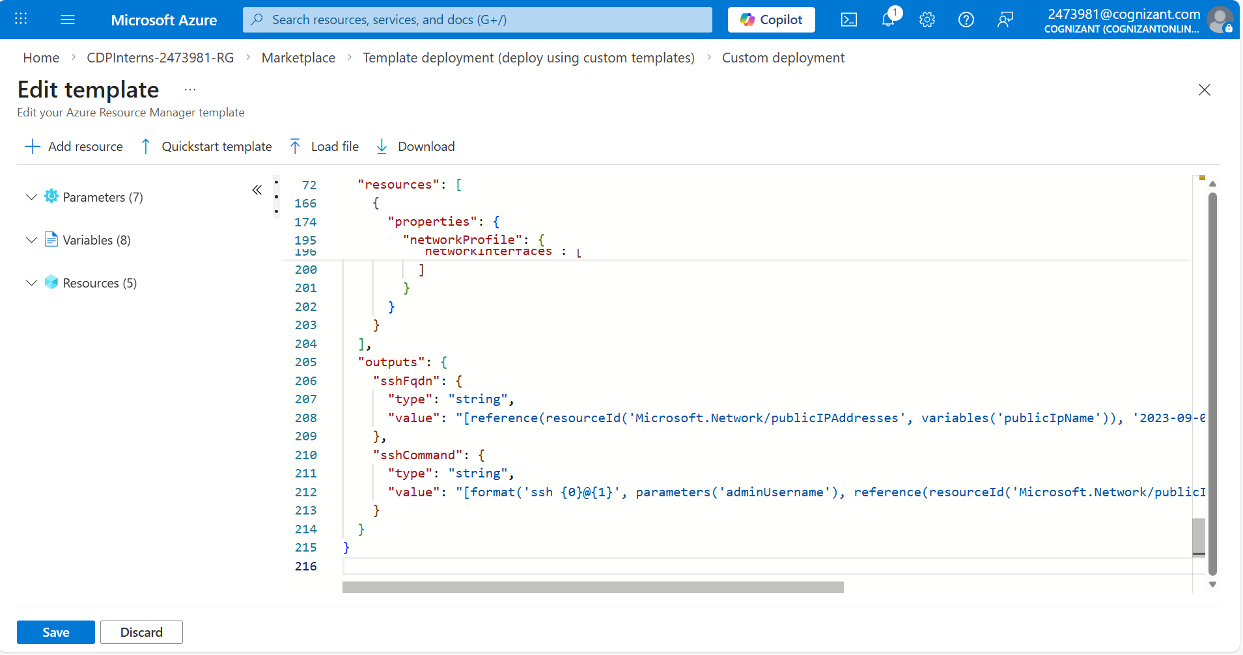
- Select Purchase. Your VM will be created in a few minutes.
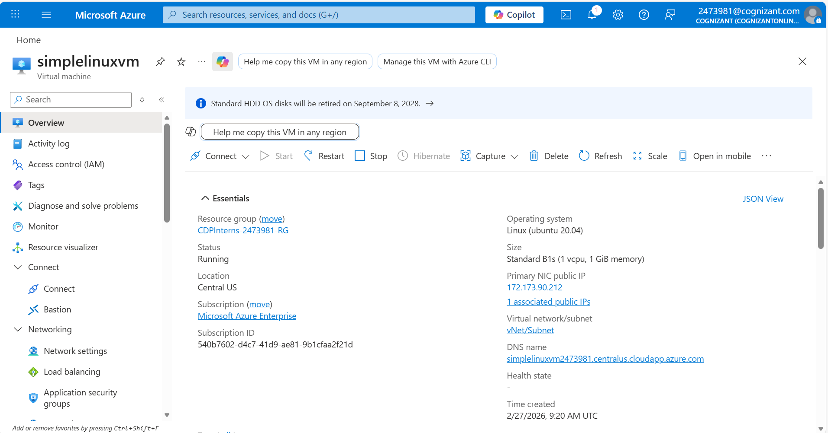

Troubleshooting
S. No | Problem | Solution
1 | Not able to create the virtual machine due to authorization failure  (Code: AuthorizationFailed) | Check beforehand the authorization given, to create this VM, if not take help from the team to give the required authorization.
2 | Unable to create the virtual machine due to policy violations  (Code: RequestDisallowedByPolicy) | Check the policy and give the valid details under the Basics and Settings that are allowed by policy.

Supporting References
Refer the below links for additional information:

1. https://docs.microsoft.com/en-us/azure/azure-resource-manager/templates/deploy-portal 2. https://docs.microsoft.com/en-us/azure/virtual-machines/windows/ps-template

